Distal Radius Fractures (Broken Wrist)
The radius is the larger of the two bones of the forearm. The end toward the wrist is called the distal end. A fracture of the distal radius occurs when the area of the radius near the wrist breaks.
Distal radius fractures are very common. In fact, the radius is the most commonly broken bone in the arm.

Description
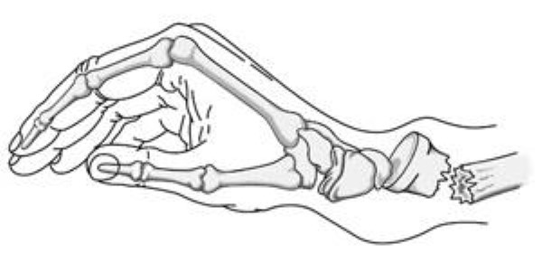
A Colles fracture occurs when the broken end of the radius tilts upward.
A distal radius fracture almost always occurs about 1 inch from the end of the bone. The break can occur in many different ways, however.
One of the most common distal radius fractures is a Colles fracture, in which the broken fragment of the radius tilts upward. This fracture was first described in 1814 by an Irish surgeon and anatomist, Abraham Colles -- hence the name "Colles" fracture.
Other ways the distal radius can break include:
- Intra-articular fracture. A fracture that extends into the wrist joint. ("Articular" means "joint.")
- Extra-articular fracture. A fracture that does not extend into the joint is called an extra-articular fracture.
- Open fracture. When a fractured bone breaks the skin, it is called an open fracture. These types of fractures require immediate medical attention because of the risk for infection.
- Comminuted fracture. When a bone is broken into more than two pieces, it is called a comminuted fracture.
It is important to classify the type of fracture, because some fractures are more difficult to treat than others. Intra-articular fractures, open fractures, comminuted fractures, and displaced fractures (when the broken pieces of bone do not line up straight).are more difficult to treat, for example.
Sometimes, the other bone of the forearm (the ulna) is also broken. This is called a distal ulna fracture.
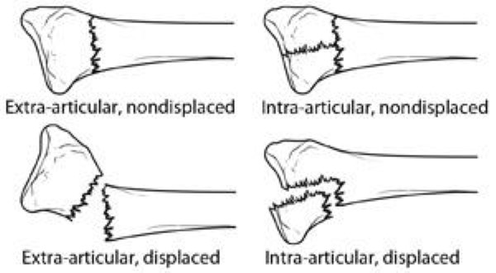
This illustration shows some of the types of distal radius fractures.
Reproduced with permission from JF Sarwark, Ed: Essentials of Musculoskeletal Care, Ed 4. Rosemont, IL, American Academy of Orthopaedic Surgeons, 2010.

Cause
The most common cause of a distal radius fracture is a fall onto an outstretched arm.
Osteoporosis (a disorder in which bones become very fragile and more likely to break) can make a relatively minor fall result in a broken wrist. Many distal radius fractures in people older than 60 years of age are caused by a fall from a standing position.
A broken wrist can happen even in healthy bones, if the force of the trauma is severe enough. For example, a car accident or a fall off a bike may generate enough force to break a wrist.
Good bone health remains an important prevention option. Wrist guards may help to prevent some fractures, but they will not prevent them all.

Symptoms
A broken wrist usually causes immediate pain, tenderness, bruising, and swelling. In many cases, the wrist hangs in an odd or bent way (deformity).

Doctor Examination
If the injury is not very painful and the wrist is not deformed, it may be possible to wait until the next day to see a doctor. The wrist may be protected with a splint. An ice pack can be applied to the wrist and the wrist can be elevated until a doctor is able to examine it.
If the injury is very painful, if the wrist is deformed or numb, or the fingers are not pink, it is necessary to go to the emergency room.
To confirm the diagnosis, the doctor will order x-rays of the wrist. X-rays are the most common and widely available diagnostic imaging technique. X-rays can show if the bone is broken and whether there is displacement (a gap between broken bones). They can also show how many pieces of broken bone there are.
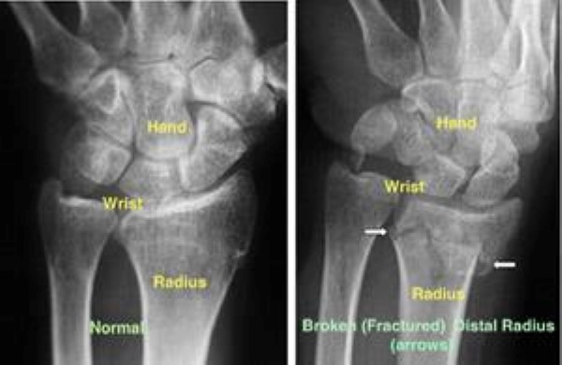
(Left) An x-ray of a normal wrist. (Right) The white arrows point to a distal radius fracture.

Treatment
Treatment of broken bones follows one basic rule: the broken pieces must be put back into position and prevented from moving out of place until they are healed.
There are many treatment options for a distal radius fracture. The choice depends on many factors, such as the nature of the fracture, your age and activity level, and the surgeon's personal preferences.

Nonsurgical Treatment
If the broken bone is in a good position, a plaster cast may be applied until the bone heals.
If the position (alignment) of your bone is out of place and likely to limit the future use of your arm, it may be necessary to re-align the broken bone fragments. "Reduction" is the technical term for this process in which the doctor moves the broken pieces into place. When a bone is straightened without having to open the skin (incision), it is called a closed reduction.
After the bone is properly aligned, a splint or cast may be placed on your arm. A splint is usually used for the first few days to allow for a small amount of normal swelling. A cast is usually added a few days to a week or so later, after the swelling goes down. The cast is changed 2 or 3 weeks later as the swelling goes down more, causing the cast to loosen.
Depending on the nature of the fracture, your doctor may closely monitor the healing by taking regular x-rays. . If the fracture was reduced or thought to be unstable, x-rays may be taken at weekly intervals for 3 weeks and then at 6 weeks. X-rays may be taken less often if the fracture was not reduced and thought to be stable.
The cast is removed about 6 weeks after the fracture happened. At that point, physical therapy is often started to help improve the motion and function of the injured wrist.

Surgical Treatment
Sometimes, the position of the bone is so much out of place that it cannot be corrected or kept corrected in a cast. This has the potential of interfering with the future functioning of your arm. In this case, surgery may be required.
Procedure. Surgery typically involves making an incision to directly access the broken bones to improve alignment (open reduction).
Depending on the fracture, there are a number of options for holding the bone in the correct position while it heals:
- Cast
- Metal pins (usually stainless steel or titanium)
- Plate and screws
- External fixator (a stabilizing frame outside the body that holds the bones in the proper position so they can heal)
- Any combination of these techniques
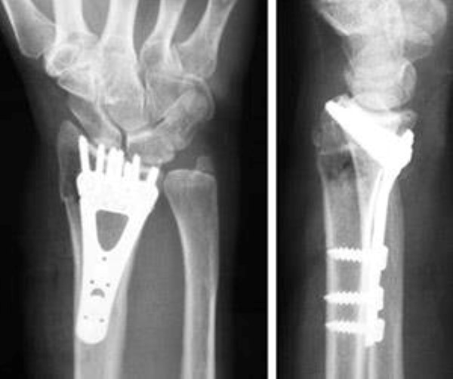
A plate and screws hold the broken fragments in position while they heal.
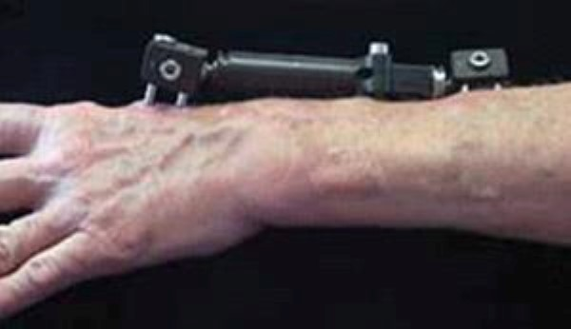
An external fixator
Open fractures. Surgery is required as soon as possible (within 8 hours after injury) in all open fractures. The exposed soft tissue and bone must be thoroughly cleaned (debrided) and antibiotics may be given to prevent infection. Either external or internal fixation methods will be used to hold the bones in place. If the soft tissues around the fracture are badly damaged, your doctor may apply a temporary external fixator. Internal fixation with plates or screws may be utilized at a second procedure several days later.

Recovery
Because the kinds of distal radius fractures are so varied and the treatment options are so broad, recovery is different for each individual. Talk to your doctor for specific information about your recovery program and return to daily activities.

Pain Management
Most fractures hurt moderately for a few days to a couple of weeks. Many patients find that using ice, elevation (holding their arm up above their heart), and simple, non-prescription medications for pain relief are all that are needed to relieve pain.
Your doctor may recommend combining ibuprofen and acetaminophen to relieve pain and inflammation. The combination of both medications is much more effective than either one alone. If pain is severe, your doctor may suggest a prescription-strength medication, such as an opioid, for a few days.
Be aware that although opioids help relieve pain after surgery, they are a narcotic and can be addictive. It is important to use opioids only as directed by your doctor. As soon as your pain begins to improve, stop taking opioids. Talk to your doctor if your pain has not begun to improve within a few days of your surgery.

Cast and Wound Care
In some cases, original casts will be replaced because swelling has gone down so much that the cast becomes loose. The last cast is usually removed after about 6 weeks.
During healing, casts and splints must be kept dry. A plastic bag over the arm while showering should help. If the cast does become wet, it will not dry very easily. A hair dryer on the cool setting may be helpful.
Most surgical incisions must be kept clean and dry for 5 days or until the sutures (stitches) are removed, whichever occurs later.

Potential Complications
After surgery or casting, it is important that you achieve full motion of your fingers as soon as possible. If you are not able to fully move your fingers within 24 hours due to pain and/or swelling, contact your doctor for evaluation.
Your doctor may loosen your cast or surgical dressing. In some cases, working with a physical or occupational therapist will be required to regain full motion.
Unrelenting pain may be a sign of Complex Regional Pain Syndrome (Reflex Sympathetic Dystrophy) which must be treated aggressively with medication or nerve blocks.

Rehabilitation and Return to Activity
Most people do return to all their former activities after a distal radius fracture. The nature of the injury, the kind of treatment received, and the body's response to the treatment all have an impact, so the answer is different for each individual.
Almost all patients will have some stiffness in the wrist. This will generally lessen in the month or two after the cast is taken off or after surgery, and continue to improve for at least 2 years. If your doctor thinks it is needed, you will start physical therapy within a few days to weeks after surgery, or right after the last cast is taken off.
Most patients will be able to resume light activities, such as swimming or exercising the lower body in the gym, within 1 to 2 months after the cast is removed or within 1 to 2 months after surgery. Vigorous activities, such as skiing or football, may be resumed between 3 and 6 months after the injury.

Long-Term Outcomes
Recovery should be expected to take at least a year.
Some pain with vigorous activities may be expected for the first year. Some residual stiffness or ache is to be expected for 2 years or possibly permanently, especially for high-energy injuries (such as motorcycle crashes), in patients older than 50 years of age, or in patients who have some osteoarthritis. However, the stiffness is usually minor and may not affect the overall function of the arm.
Finally, osteoporosis is a factor in many wrist fractures. It has been suggested that people who have a wrist fracture should be tested for bone weakness, especially if they have other risk factors for osteoporosis. Ask your doctor about osteoporosis testing. (Adapted from OrthoInfo AAOS)
Gordon I Groh MD, MBA Asheville Orthopedic Associates American Shoulder and Elbow Surgeons An affiliate of Mission Health American Society for Surgery of the Hand 111 Victoria Avenue or 310 Long Shoals Road American Academy of Orthopedic Surgeons Asheville, North Carolina 28801 828 252 7331 www.DrGordonGroh.com Shoulder, Elbow and Hand Surgery

