What is a Hand Surgeon?
Our hands serve many purposes. Hands help us eat, dress, write, earn a living, create art, and do many other activities. To function, our hands require sensation and movement in the joints, tendons and muscles. . When a problem takes place in the hand, care must be given to all the different types of tissues that make function of the hand possible.
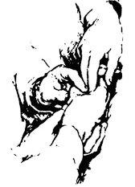
This drawing was made from a photograph taken in 1946 of two founding members of the American Society for Surgery of the Hand. Sterling Bunnell, MD, and J. William Littler, MD, are examining the hand of a patient.

What do hand surgeons do?
Hand surgery is the field of medicine that deals with problems of the hand, wrist, and forearm. Hand surgeons care for these problems with and without surgery. They are specially trained to operate when necessary. Many hand surgeons are also experts in diagnosing and caring for shoulder and elbow problems.
Hand surgeons are orthopaedic, plastic, or general surgeons who have additional training in surgery of the hand. To become members of the American Society for Surgery of the Hand, hand surgeons must take a full year of additional training and must pass a rigorous certifying examination.
Some hand surgeons treat only children, some treat only adults, and some treat both.

Why visit a hand surgeon?
If you have pain in your fingers, hand, wrist or arm, or have other upper-extremity related concerns, you may want to consult a hand surgeon. Because many hand surgeons devote most of their time to examining, treating and studying the hand, they are specialists in hand care.

Not every visit to a hand surgeon results in hand surgery.
Hand surgeons often recommend non-surgical treatment options, including hand therapy, a combination of physical and occupational therapy to restore movement and reduce or eliminate pain.

Examples of conditions treated by a hand surgeon are:
- Carpal tunnel syndrome
- Wrist pain
- Cuts on the fingers and hand
- Sports injuries to the hand and wrist
- Creating fingers from toes and other joints
(Adapted from OrthoInfo AAOS)
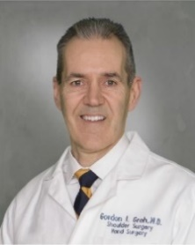
Gordon I Groh MD, MBA Asheville Orthopedic Associates American Shoulder and Elbow Surgeons An affiliate of Mission Health American Society for Surgery of the Hand 111 Victoria Avenue or 310 Long Shoals Road American Academy of Orthopedic Surgeons Asheville, North Carolina 28801 828 252 7331 www.DrGordonGroh.com Shoulder, Elbow and Hand Surgery

