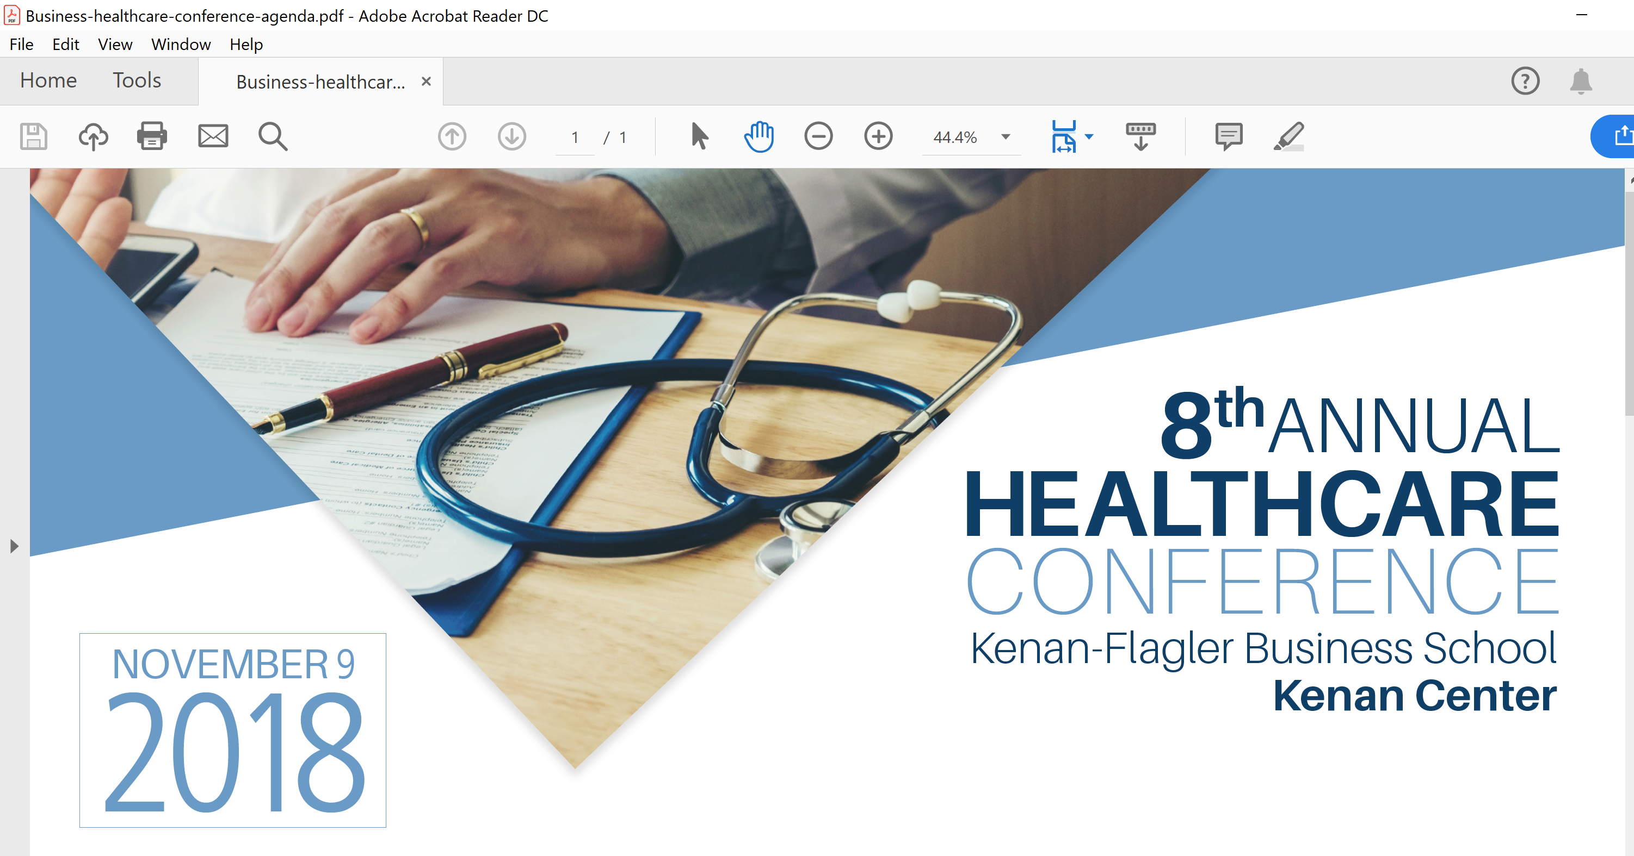
UNC Chapel Hill Kenan Flagler Business School hosted its 8th annual Healthcare Conference. The conference is now organized by the UNC Kenan Flagler Center for the Business of Health—where I serve on the leadership council.
I was fortunate to moderate a session on Pharmaceutical pricing. We enjoyed a robust discussion due to the expertise of the panel:
- Susanne Laningham, Executive Director of Global Value, Access & Policy at Amgen Inc.
- Sean Callinicos, SVP, Global Government Relations & Public Policy, Cardinal Health
- Shawn Davis, Sr. Director, Pharma Strategy and Contracting, Express Scripts
Additional thanks are due to:
Professors Staats and Saba—Executive Leadership Center for the Business of Health
UNC Healthcare Club—Instrumental in organizing the conference
Saurabh Guleria—my MBA liaison for the conference
The conference was an outstanding success both in attendance and participation—looking forward to next year!

